Appendix
Appendix Figure 1. Lorlatinib PFS Survival Extrapolations.
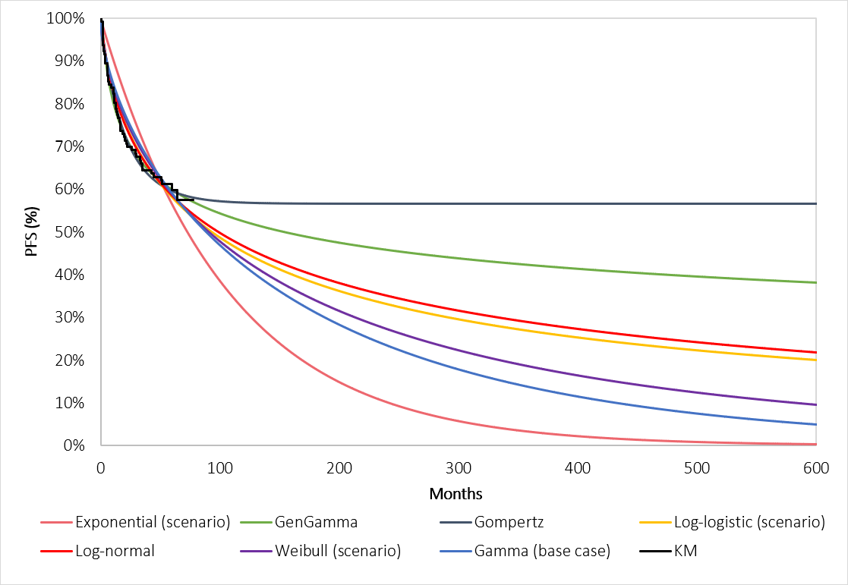
KM, Kaplan-Meier; PFS, progression-free survival.

Appendix Table 1. Lorlatinib PFS Extrapolation Goodness of Fit.
Distribution | AIC | AIC rank | BIC | BIC rank
Exponential | 623.98 | 7 | 626.98 | 7
Generalised gamma | 600.00 | 1 | 609.02 | 2
Gompertz | 602.60 | 2 | 608.61 | 1
Log-logistic | 607.92 | 4 | 613.93 | 4
Log-normal | 603.58 | 3 | 609.59 | 3
Weibull | 610.96 | 5 | 616.97 | 5
Gamma | 612.75 | 6 | 618.76 | 6
AIC, Akaike Information Criterion; BIC, Bayesian Information Criterion.

Appendix Figure 2. Lorlatinib OS Survival Extrapolations.
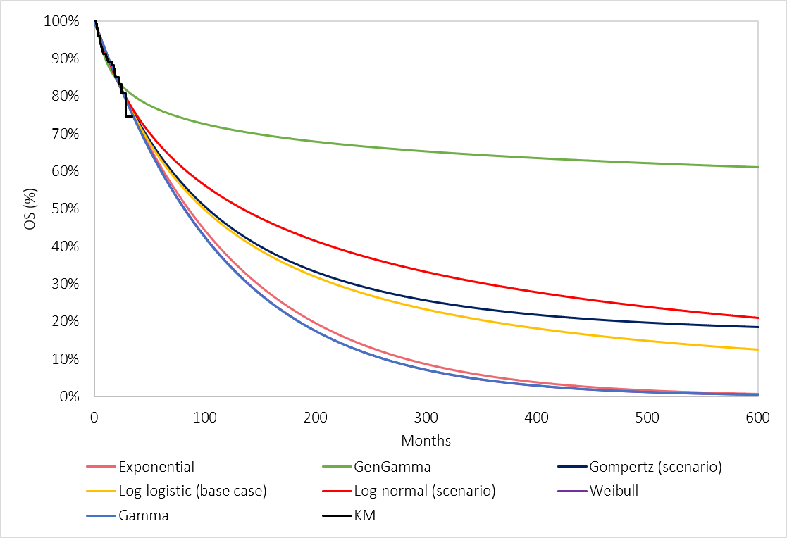
KM, Kaplan-Meier; OS, overall survival.

Appendix Table 2. Lorlatinib OS Extrapolation Goodness of Fit.
Distribution | AIC | AIC rank | BIC | BIC rank
Exponential | 269.29 | 1 | 272.30 | 1
Generalised gamma | 270.32 | 3 | 279.33 | 7
Gompertz | 271.27 | 6 | 277.27 | 5
Log-logistic | 271.12 | 4 | 277.12 | 3
Log-normal | 269.85 | 2 | 275.86 | 2
Weibull | 271.27 | 7 | 277.28 | 6
Gamma | 271.25 | 5 | 277.26 | 4
AIC, Akaike Information Criterion; BIC, Bayesian Information Criterion.

Appendix Table 3. Landmark Survival Estimates from Base Case Extrapolations.
Treatment | 5 years | 10 years | 15 years | 20 years
Lorlatinib PFS | 59.2% | 42.2% | 31.2% | 23.5%
Alectinib PFS | 38.3% | 20.6% | 11.8% | 7.0%
Lorlatinib OS | 63.6% | 44.9% | 34.4% | 27.7%
Alectinib OS | 62.5% | 34.2% | 19.0% | 10.9%
OS, overall survival; PFS, progression-free survival.

Appendix Table 4. Grade 3+ Adverse Event Inputs²³.
Adverse event | Lorlatinib incidence | Alectinib incidence | Duration (days) | Disutility per Event
Hypertriglyceridemia* | 66.44% | 0.00% | 714 | -0.037
Weight increased | 22.82% | 0.00% | 778 | -0.037
Increased lipase level | 6.04% | 0.00% | 30 | -0.037
Hypercholesterolemia* | 72.48% | 0.00% | 770.5 | -0.037
Aspartate aminotransferase increased | 2.01% | 5.26% | 30 | -0.037
Gamma-glutamyltransferase increased | 6.04% | 0.00% | 30 | -0.037
Hypertension | 12.08% | 0.00% | 30 | -0.037
Anaemia | 4.03% | 5.92% | 30 | -0.037
Amylase increased | 0.00% | 0.00% | 30 | -0.037
Neutropenia | 0.67% | 0.00% | 30 | -0.090
Blood creatine phosphokinase increased | 2.68% | 3.29% | 30 | -0.037
Neutrophil count decreased | 0.00% | 0.00% | 30 | -0.037
Peripheral neuropathy* | 43.62% | 0.00% | 380 | -0.090
Cognitive effects* | 27.52% | 0.00% | 221 | -0.090
Mood effects* | 20.81% | 0.00% | 218 | -0.090
*Includes adverse events of all grades for lorlatinib (based on number of total events divided by total patients in the treatment arm (149)), as these were deemed of special interest following the preferred assumptions in the original submission to NICE.
Appendix Figure 3. Probabilistic Sensitivity Analysis Scatterplot.
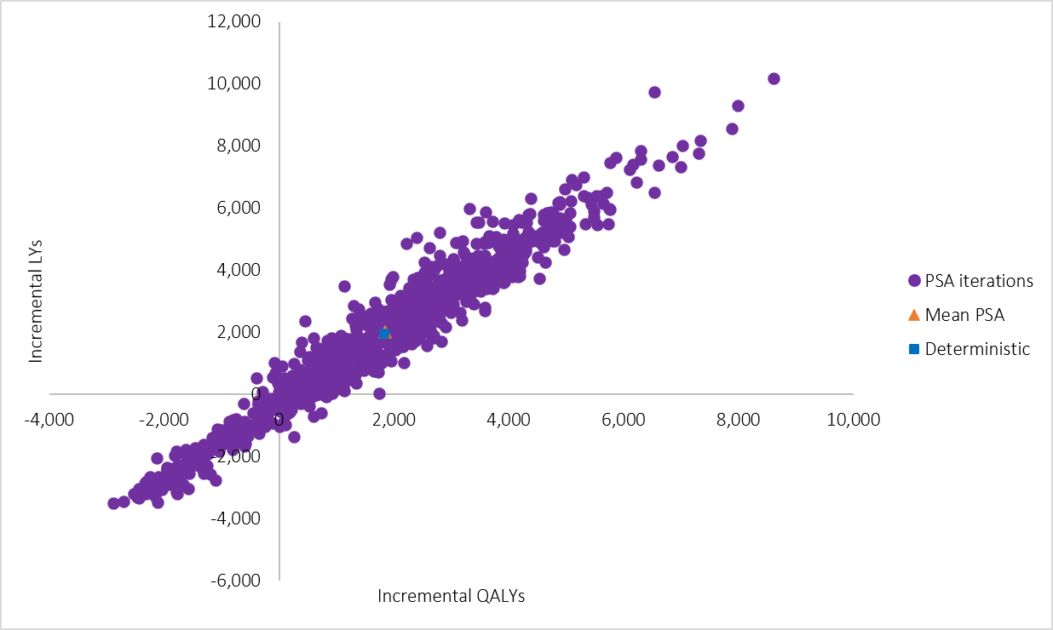
LY, life year; PSA, probabilistic sensitivity analysis; QALY, quality-adjusted life year.

